**Assignment-5**

**1. Write a C program to find sum of each row and columns of a matrix.**

CODE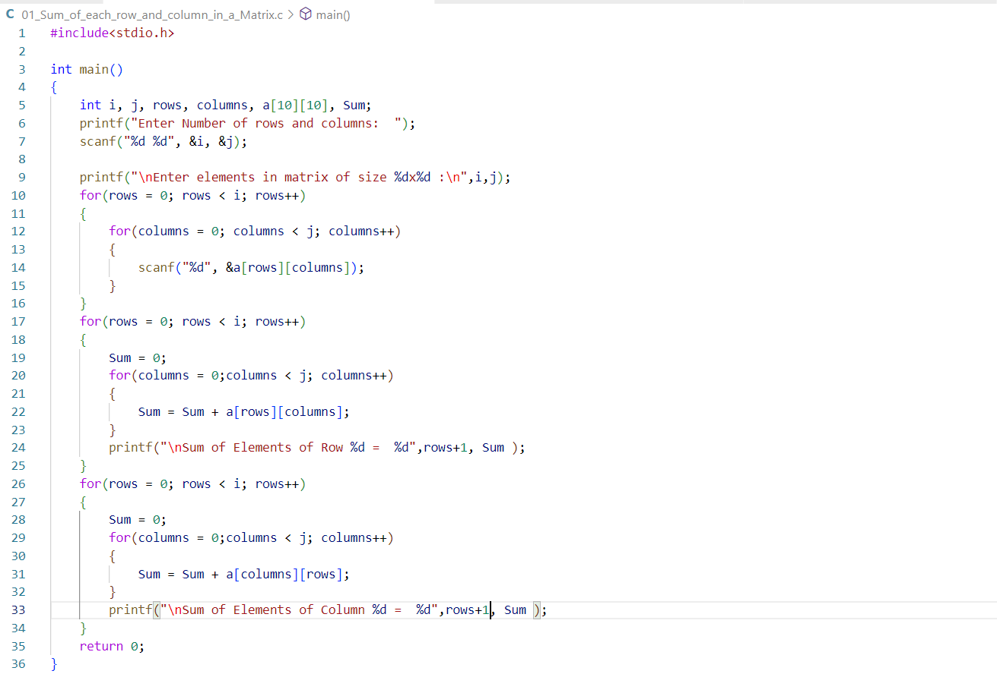

OUTPUT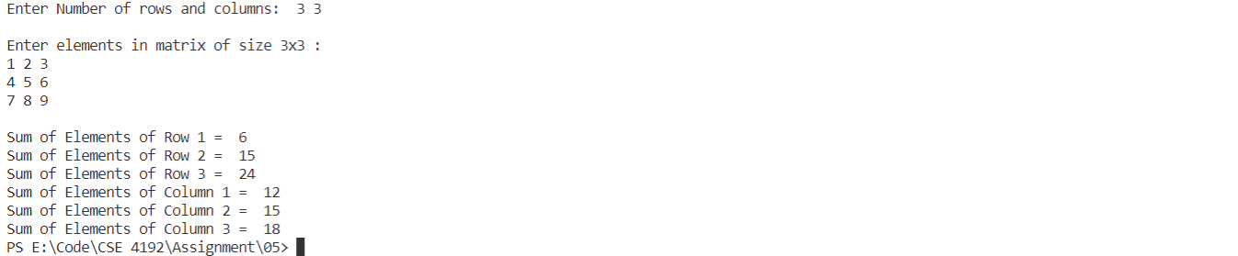

**2.Write a C program to put even and odd elements of array in two separate array.**

**Input**

Input size of the array: 10

Input elements in array: 0 1 2 3 4 5 6 7 8 9

**Output**

Output even elements in array: 0 2 4 6 8

Output odd elements in array: 1 3 5 7 9

CODE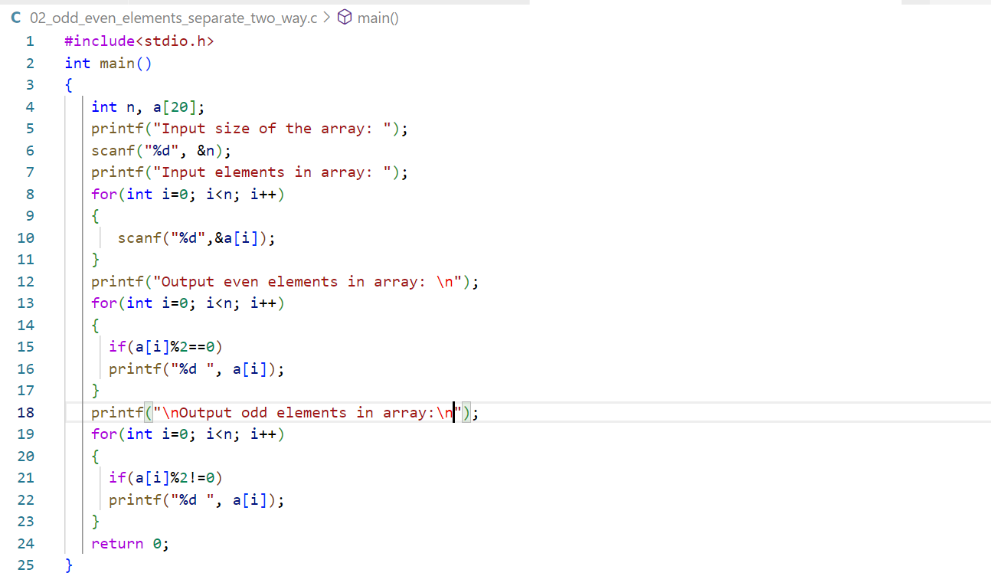

OUTPUT

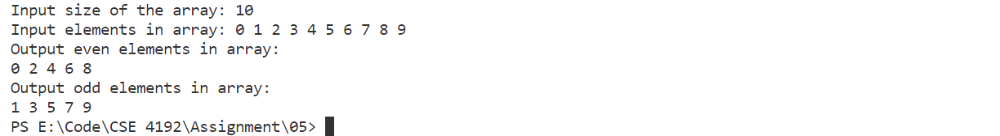

**3.Write a C program to find the multiplication of two matrix.**

CODE 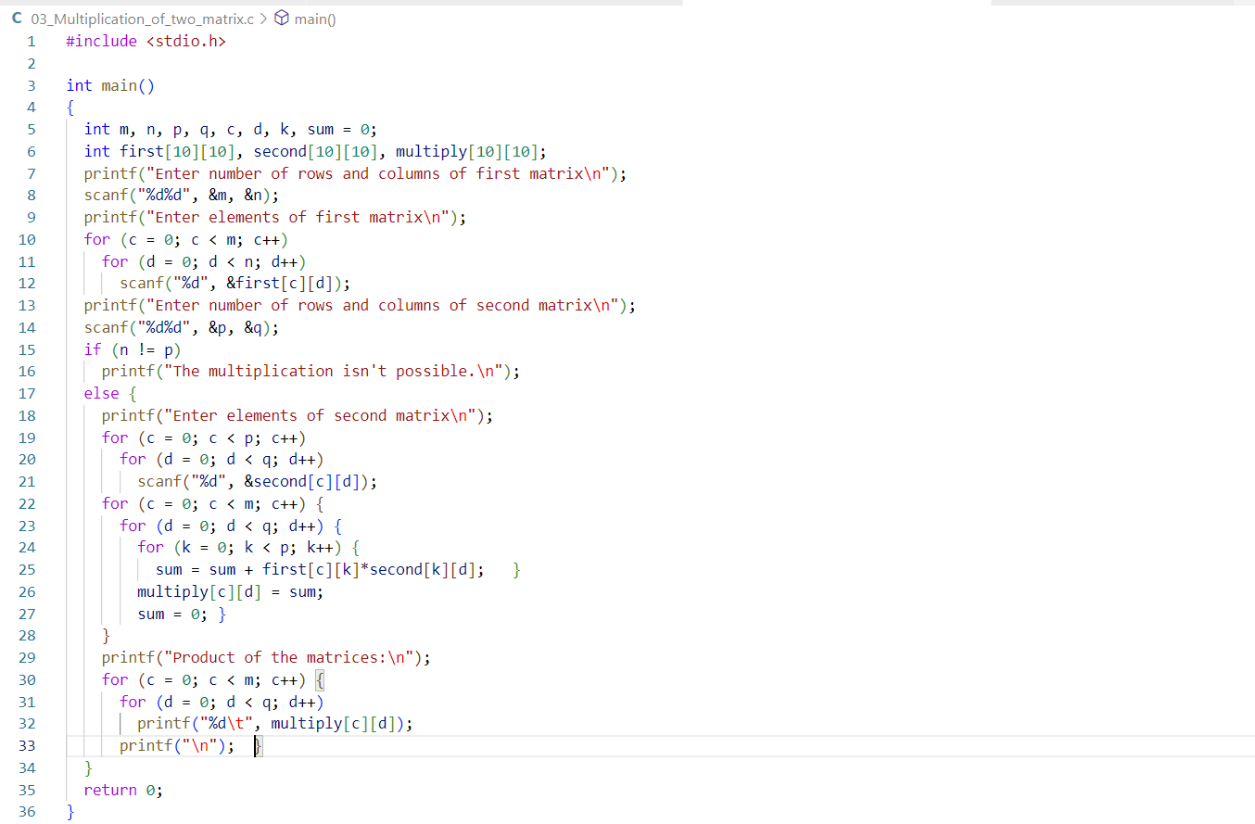

OUTPUT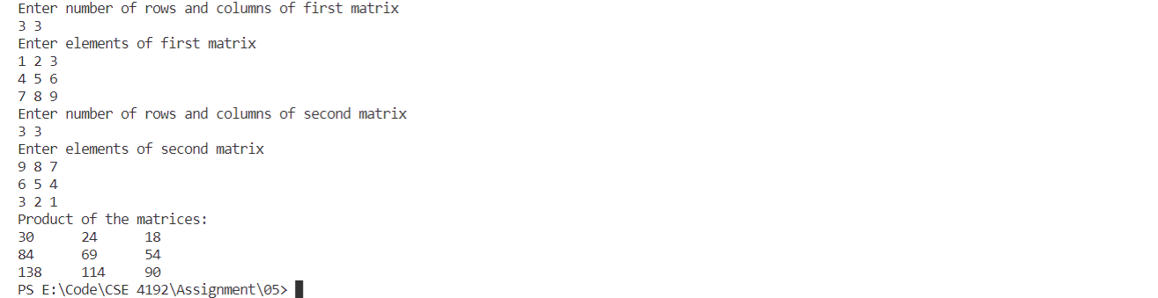

**4. Write a C program to delete duplicate elements from array.**

**Input**

Input array elements: 10, 20, 10, 1, 100, 10, 2, 1, 5, 10

**Output**

After removing all duplicate elements

Elements of array are: 10, 20, 1, 100, 2, 5

CODE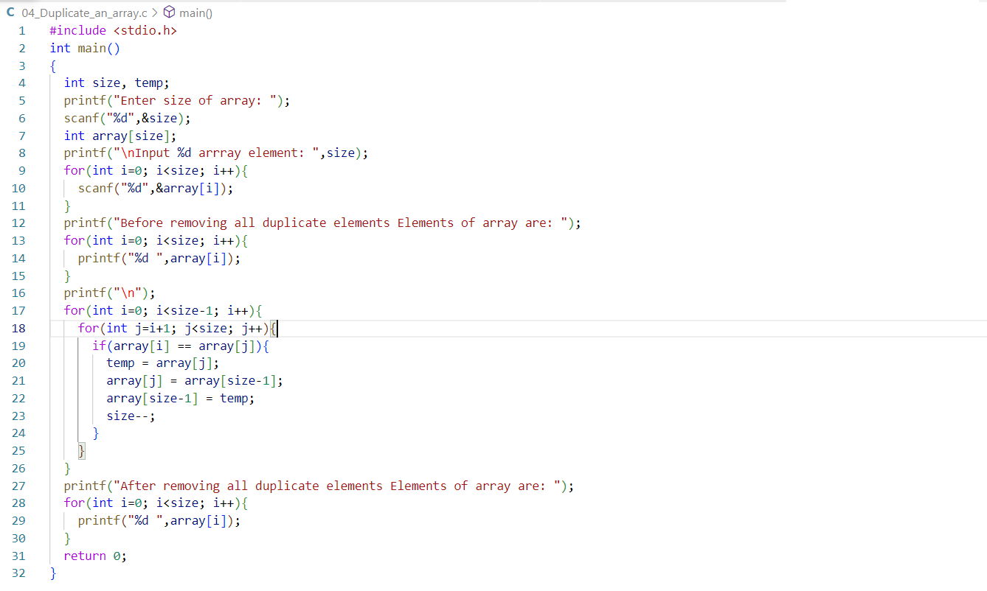

OUTPUT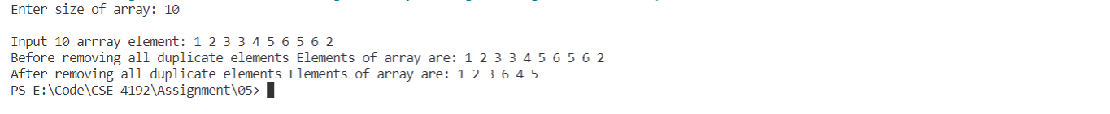

**Lab-5**

**1. Write a C Program for Create a two matrix.**

CODE

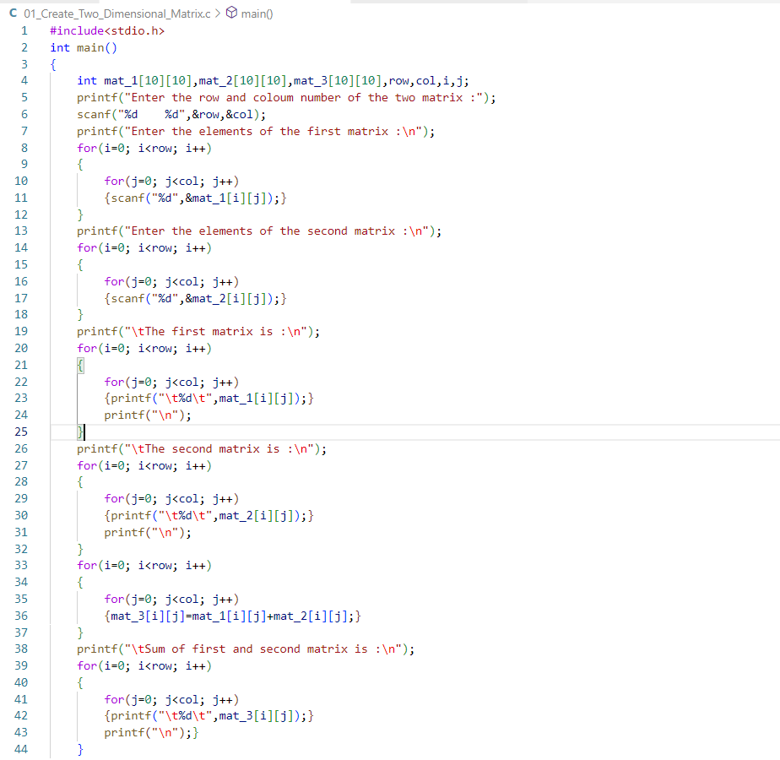

OUTPUT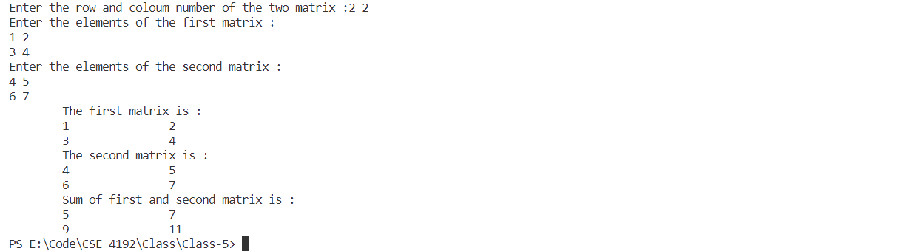

**2. Write program in c sum of two matrix.**

CODE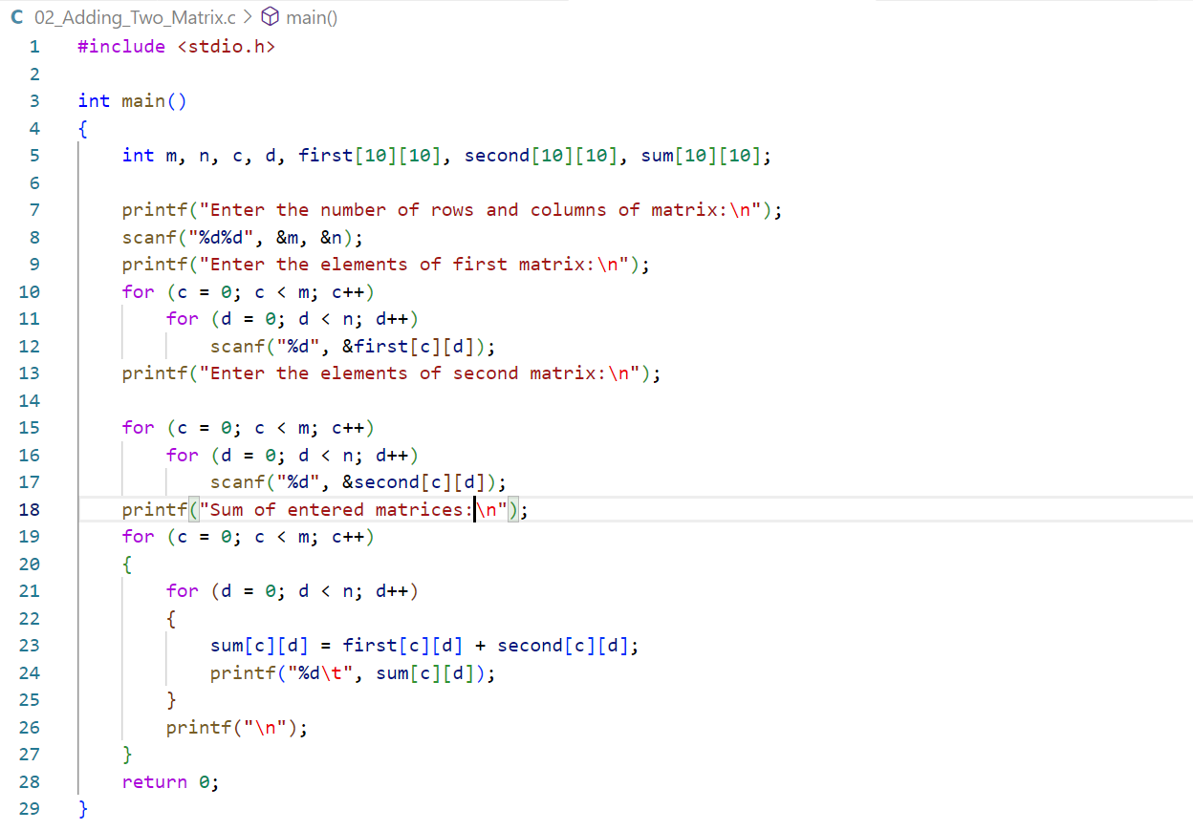

OUTPUT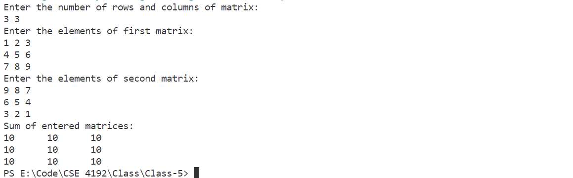

**3. Write a program in C find transpose of a matrix.**

CODE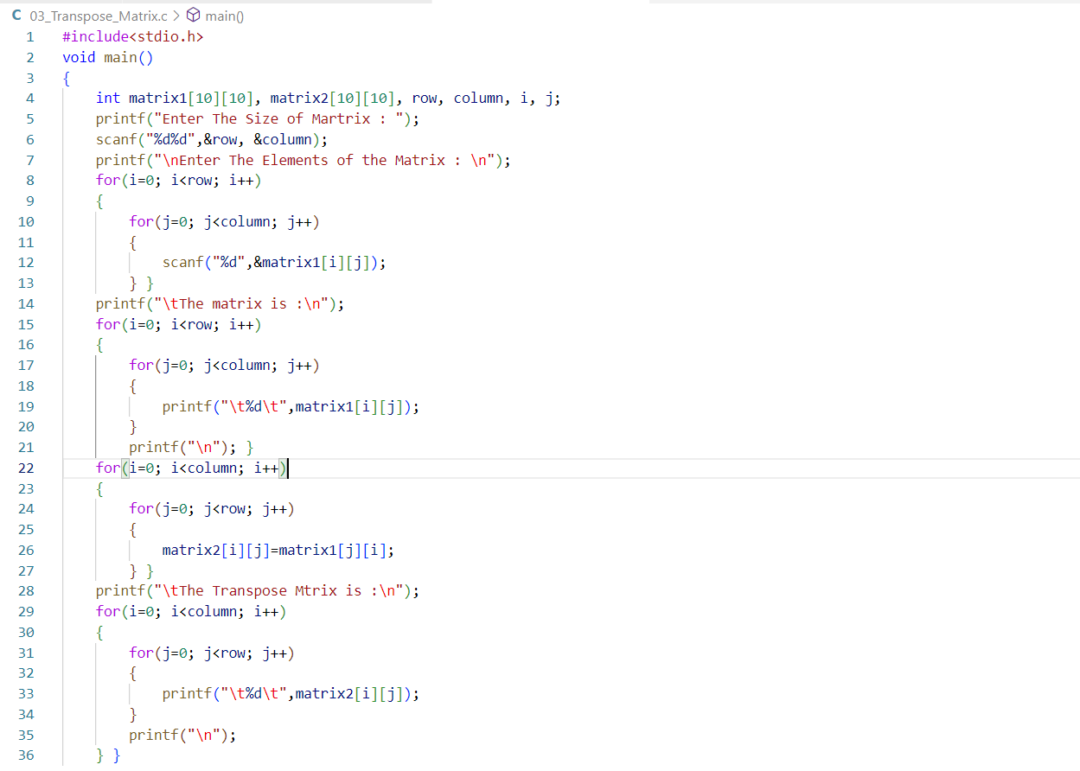

OUTPUT